7 Software Design
The preceding chapter established the physical and electrical architecture of the display unit. This chapter sets out the software that makes it work: the control logic that regulates the speed of the rotating arm, the position handling that tells the arm where it is pointing, the image representation that turns a picture into a sequence of illuminated columns, the wireless coordination between the processors, and the interface through which a member of the public operates the unit. It also covers what the software does when something goes wrong.
Three requirements shape almost every decision that follows. The rotating assembly is electrically isolated, so nothing can be coordinated by wire (Section 6.1). The user interface must be usable from an ordinary phone or laptop with nothing installed (SR12, FR05). And the firmware itself is to be custom-developed rather than assembled from ready-made display libraries (FR12). Each of these removes an easy option and forces a design decision that has to be argued rather than assumed.
The software is divided across three microcontrollers, matching the three physical subsystems. The stator processor is stationary and mains powered; it runs the motor control loop, hosts the wireless access point and web server the user connects to, stores the content library, and relays that content onward. The rotor processor rotates with the arm; it senses the angular datum, derives the arm's instantaneous angle, and clocks the correct column of colour data out to the LED strip. The linear rail processor would handle lateral positioning, and is not implemented within the scope of this work. No wire crosses either the rotating interface or the translating carriage, so all three coordinate wirelessly.
The chapter is organised to follow that division. Section 7.1 sets out the architecture and the allocation of function between the processors. Section 7.2 addresses the real-time problem created by running motor control and a web server on a single processor core. Sections 7.3 and 7.4 cover motor control and rotational position measurement respectively. Section 7.5 describes how an image is represented and displayed, and defends the most significant departure from the original specification. Sections 7.6 and 7.7 cover the link between the processors and the user interface, and Section 7.8 covers fault detection and safety. Measured performance is reported separately, in Chapter 8.

7.1 Architecture Overview
The constraint that determines the whole architecture is that no electrical connection crosses the rotating interface. The decoupled, battery-powered concept selected in Chapter 5 places an independent power source and an independent processor on the arm itself, eliminating the slip ring or wireless power transfer that a powered rotating interface would otherwise require. The consequence for the software is that the rotor cannot be commanded over a wire, cannot be clocked over a wire, and cannot share a memory or a timebase with anything else. Every piece of coordination between the two halves of the machine is a radio message, with the latency and the loss characteristics that implies.
Function is therefore allocated according to where the relevant hardware physically is, and according to which node can be relied upon. The arrangement is shown in Figure 15.
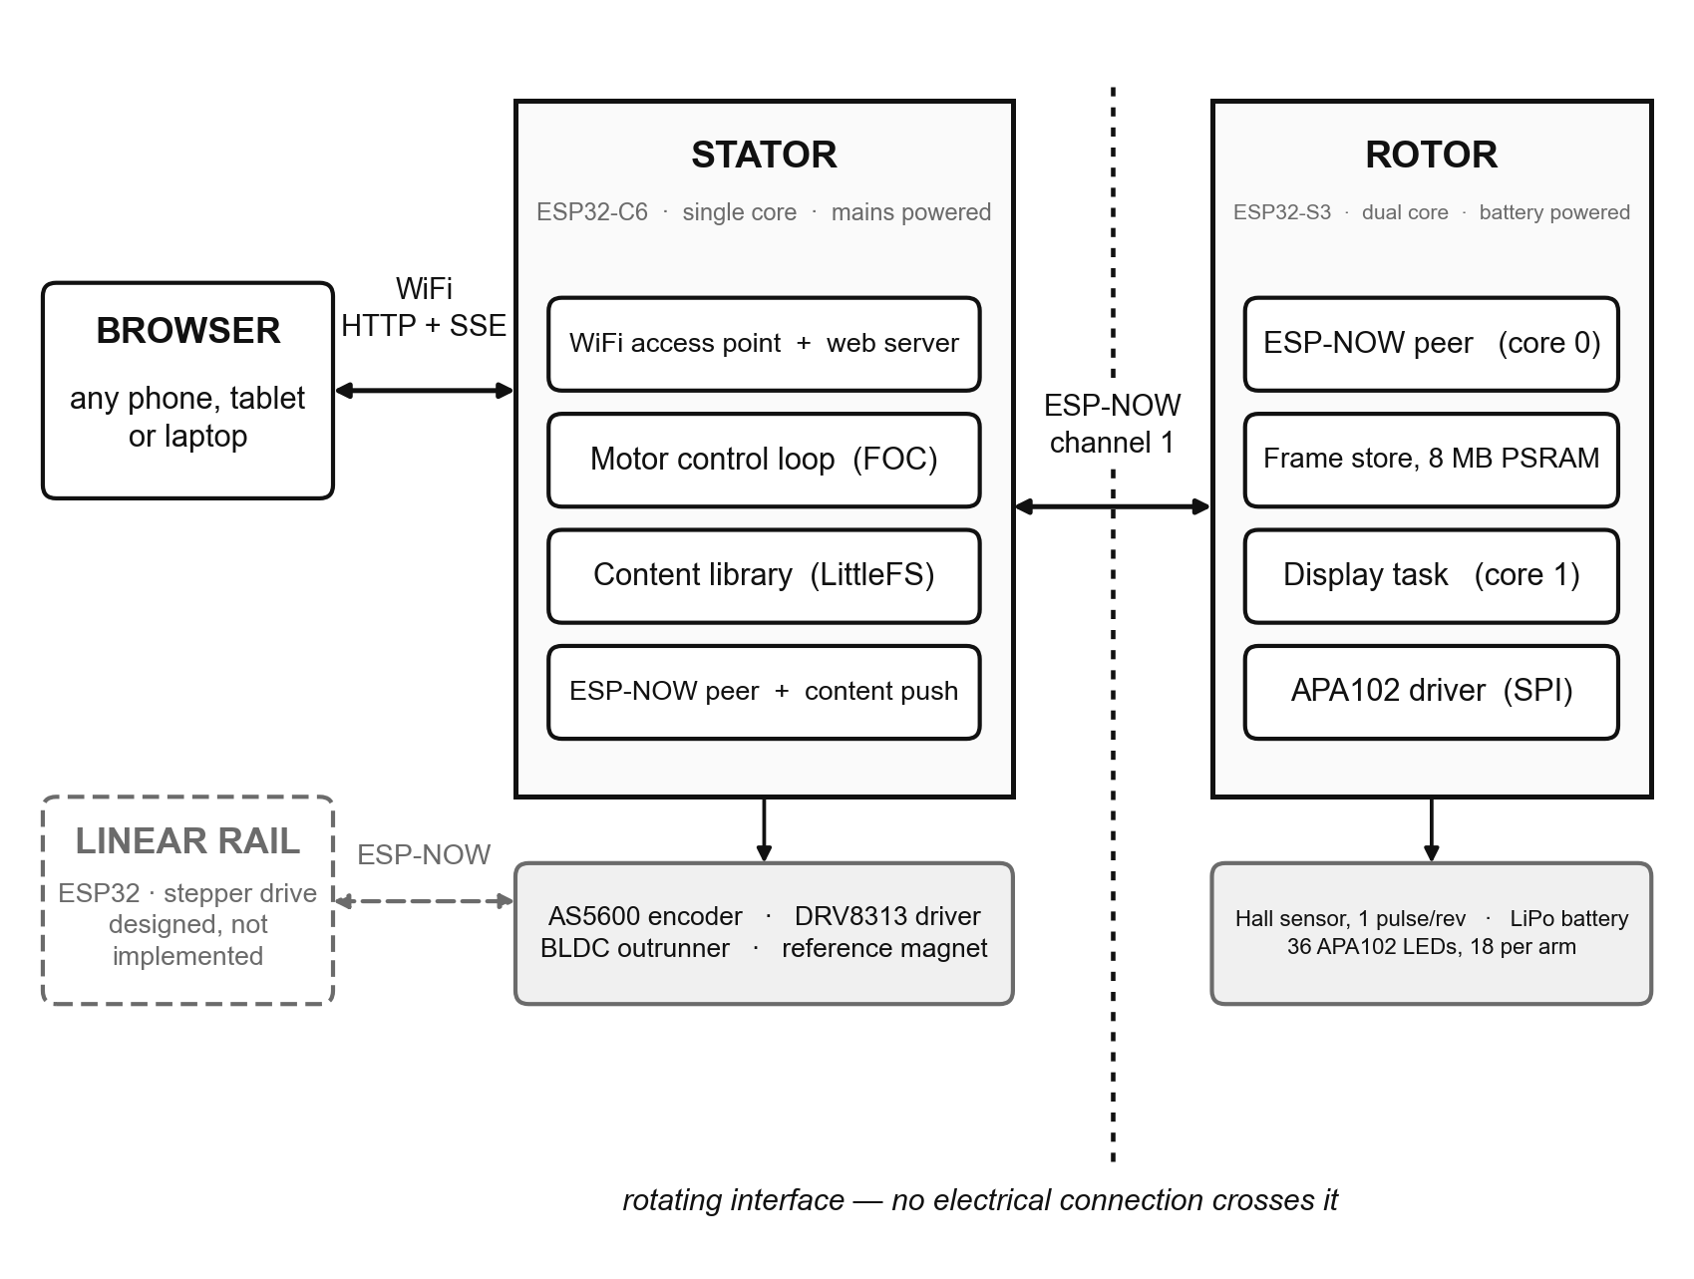
Figure 15: System architecture: the three processors, the peripherals attached to each, and the wireless links between them.
The stator processor hosts the user interface. It is the natural choice for three reasons: it is mains powered, so serving a web page costs it nothing it does not already have; it is stationary, so a client associates with a radio that is not moving; and it is the node that owns the motor, which is what the majority of user commands act upon. Placing the server on the rotor would spend the arm's battery on network traffic, and would require the user's device to hold an association with a transmitter rotating at several revolutions per second.
The rotor processor drives the display. This is not merely a convenience of wiring, although the LED strip is of course mounted on the arm. It is that the display has a hard timing requirement — a fresh column of colour is due every few hundred microseconds at the design speed — and that requirement is best met by a processor that has nothing else to do. The rotor processor selected for the build has two cores, which allows the display loop to be given one of them outright while the radio runs on the other. This is examined further in Section 7.2, because it stands in deliberate contrast to the stator, which has only one core.
The path an image takes from the user to the illuminated strip crosses all three tiers, and is shown in Figure 16. A source file is decoded and converted in the browser, uploaded to the stator over the wireless network, stored in the stator's flash memory, transferred once to the rotor's memory over the inter-processor link, and thereafter read out of that memory column by column as the arm turns. The reasons for splitting the work at exactly these points are given in Sections 7.5 and 7.6.
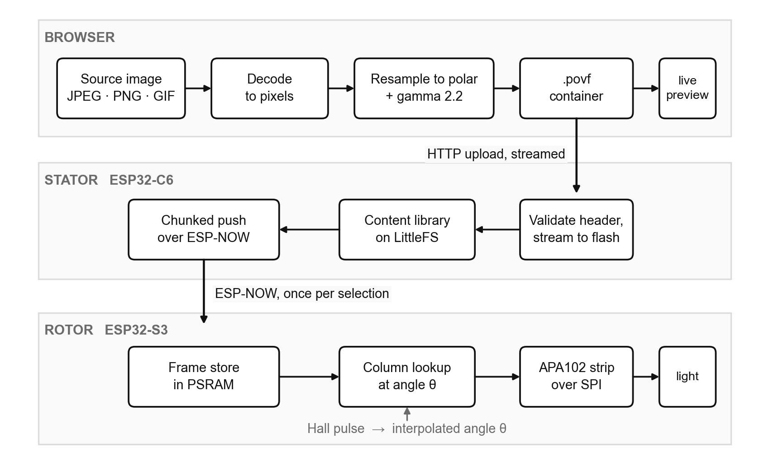
Figure 16: Data flow from a source image to an illuminated LED, showing which processor performs each stage.
In respect of FR12, the display driver, the angular position handling, the image addressing, the inter-processor protocol and the web server integration were all written for this project from first principles; an established field-oriented control library was used for the low-level commutation of the brushless motor, and was configured, bounded and integrated as part of this work.

7.2 Real-Time Design and Task Scheduling
The stator processor has a single processor core, and three demands are made of it concurrently: it must run the motor control loop, it must maintain a wireless access point, and it must serve the web interface to whoever is connected to that access point. There is no second core to which the control loop can be moved. This is the largest technical risk in the software design, and the arrangement described here is deliberate rather than incidental.
The risk runs in both directions, and the two failure modes are asymmetric. If the control loop is starved, the motor's speed regulation degrades; if it is starved badly enough, the sampling of the angle sensor becomes too infrequent for the velocity estimate to be meaningful at all. If the network stack is starved, the access point drops, and with it the entire user interface — which is to say the whole of SR11 and SR12 fails, and the operator loses the ability to stop the fan from the interface. Protecting the control loop by giving it unconditional priority would therefore trade a mild degradation for a total one.
Three approaches were considered. Running the control loop in a continuous busy loop at the highest priority guarantees its timing but starves the radio, and was rejected on the grounds above. Moving the web server onto a second processor removes the conflict entirely, but requires an additional board and additional cost, and would place the interface on a node that does not own the motor. The approach adopted instead combines a priority ordering with cooperative yielding, and is illustrated in Figure 17.
The priority ordering places the control loop above the web server but below the network stack. The web server therefore cannot delay a control iteration, which is the interference that matters, while the radio retains the ability to pre-empt the control loop for the short, bounded work it performs. The control loop, in turn, does not run continuously. It executes a bounded burst of control iterations and then sleeps for a full scheduler tick, giving up the processor whether or not anything else is waiting for it. Roughly half the processor is allocated to control and half to everything else. That sleep is what allows a task of lower priority to run at all; without it, the web server would never execute and the network stack would be squeezed into whatever it could pre-empt.
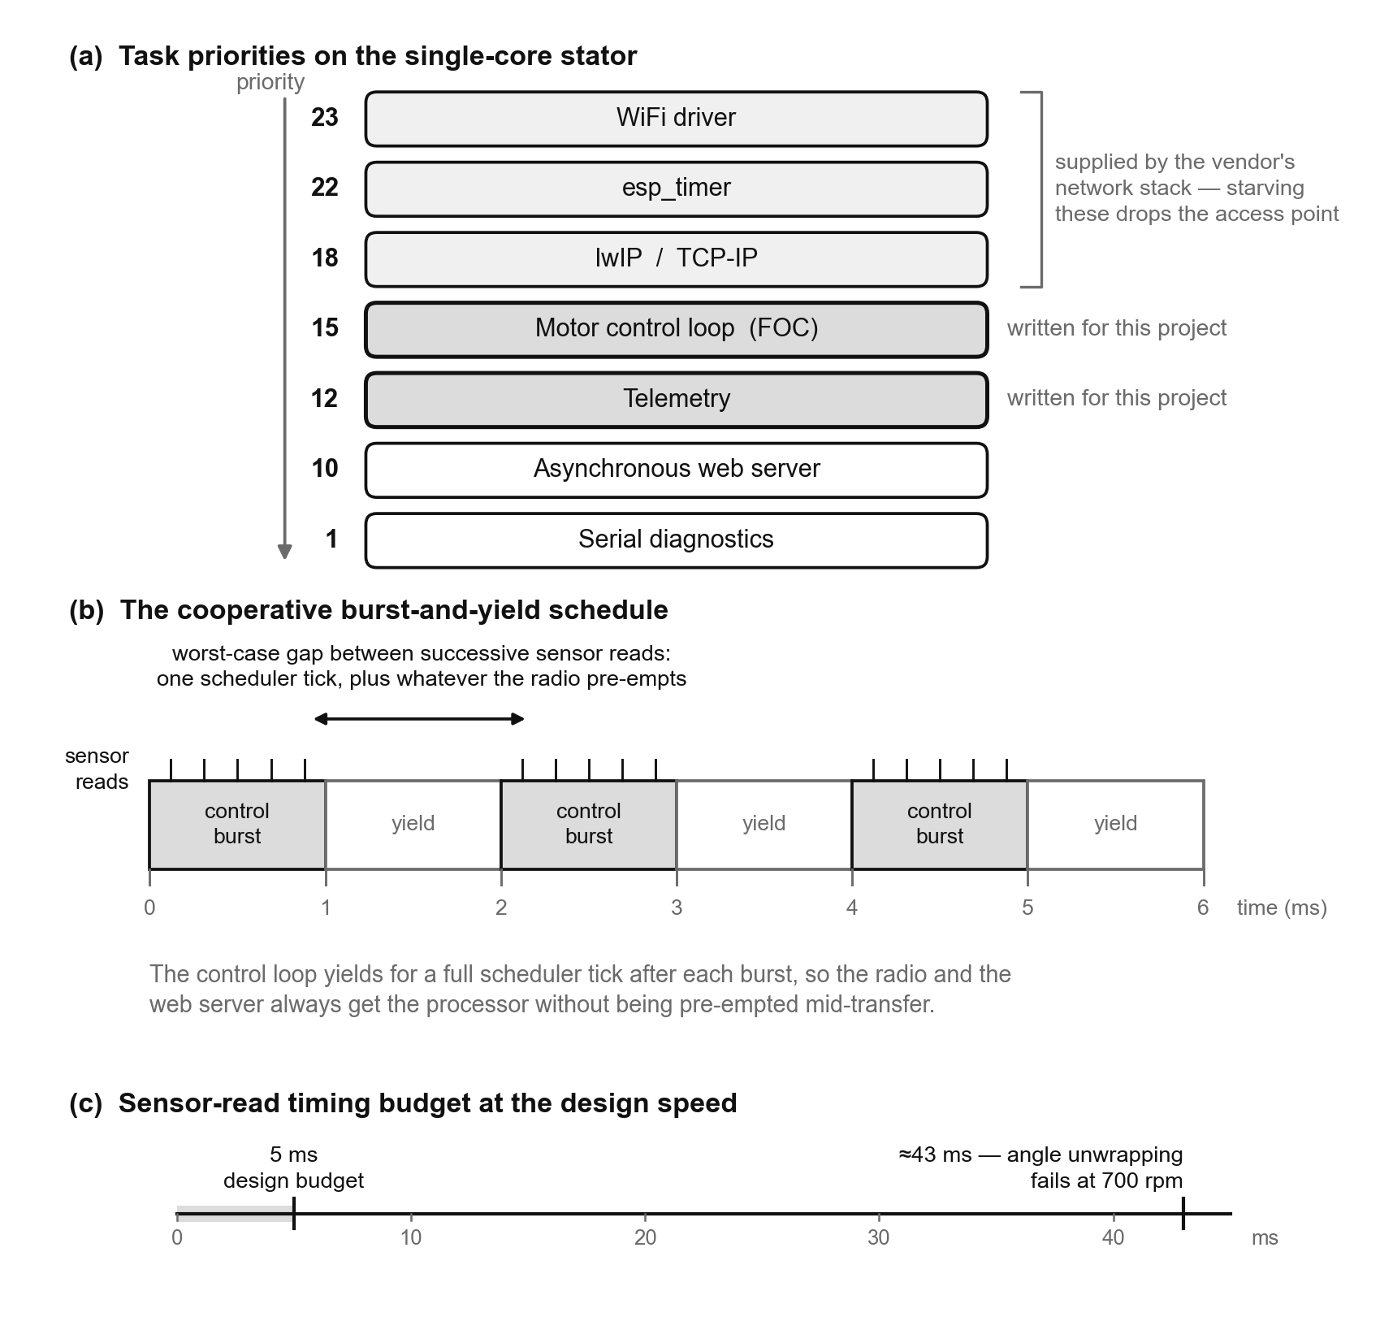
Figure 17: Real-time arrangement on the single-core stator: (a) the task priority ordering, (b) the cooperative burst-and-yield schedule, and (c) the timing budget the schedule is designed to meet.
A second rule supports the first: the web request handlers never act on the motor directly. A request arriving over the network is translated into a command and placed on a queue, and the control task performs it at the start of its next burst. The motor state therefore has a single owner and needs no locking on the control path, and an arbitrarily slow or malformed network request cannot hold up a control iteration. The one exception is the emergency stop, which sets a flag that the control loop tests directly rather than being queued, so that it cannot wait behind whatever else a browser has just submitted.
The timing budget was set from the failure point rather than from what seemed comfortable. At the design speed of 700 rpm (TPM01) a revolution takes 85.7 ms. Recovering total shaft rotation from a sensor that reports absolute angle within a single turn requires that successive samples be separated by less than half a revolution; beyond that, the direction of travel between samples becomes ambiguous and the velocity estimate is no longer recoverable. That places the failure point at roughly 43 ms. A design target of 5 ms for the worst gap between successive sensor reads was adopted, giving approximately eight times margin on the failure point.
The criterion is deliberately the worst gap rather than the average sampling rate, because the two say different things. An average rate can look entirely healthy while a single long stall corrupts the velocity estimate, and it is the single stall that does the damage. The firmware therefore records the largest gap observed since start-up as a high-water mark and reports it in the telemetry stream, so that the question is settled by a measurement rather than by an argument. The measured figures are given in Chapter 8.
One case is known not to be protected by the priority scheme, and is stated here rather than discovered later. Writing to the flash filesystem disables the processor's instruction cache while the write is in progress, and code executing from flash — including the control loop — cannot run during that window regardless of its priority. Content upload is therefore the one activity that can stall the control loop, and the appropriate response, if it proves to matter, is to refuse uploads while the arm is turning rather than to adjust any scheduling parameter.
The rotor presents the same problem in a much easier form, and the contrast is worth drawing because it justifies the allocation of function in Section 7.1. The rotor processor has two cores. The display loop is pinned to one of them and the radio is left on the other, so the timing of a column can never be affected by a packet arriving. No burst-and-yield arrangement is needed, and no priority argument has to be made. Placing the display on the dual-core processor and the web server on the single-core one puts the harder real-time requirement on the processor that can absorb it.

7.3 Motor Control
The arm must be rotated (FR04) at a speed high enough for the persistence-of-vision effect to produce a stable image (SR13, TPM01). The requirement on the software is not simply to reach that speed, however, but to hold it. As Section 7.4 explains, the rotor establishes the arm's angular position by interpolating between once-per-revolution pulses using the duration of the preceding revolution, so a speed that varies from one revolution to the next appears directly as angular error in the image. Speed stability is an image-quality requirement, not only a motor requirement.
That consideration decides open-loop against closed-loop control immediately. An open-loop scheme — commutating at a fixed rate, or applying a fixed voltage — allows the actual speed to vary with load, supply voltage and temperature, and offers no means of detecting that it has. Since the concept evaluation in Chapter 5 already identified position feedback as the weakness of the open-loop arrangement, and since a magnetic encoder is integrated into the selected motor, closed-loop velocity control was adopted. Field-oriented control was used for the commutation itself in preference to a simpler six-step scheme, because it produces smoother torque and less cogging; on a long, comparatively light arm, torque ripple is felt as vibration, and Section 7.8 relies on velocity ripple being a meaningful indicator of mechanical imbalance rather than an artefact of the commutation.
The resulting control structure is shown in Figure 18. The encoder provides absolute shaft angle; angle is differentiated and low-pass filtered to give a velocity estimate; that estimate is subtracted from the commanded speed, and the error drives a proportional-integral controller whose output is the quadrature-axis voltage passed to the modulator. The same encoder angle is used for commutation, so a single sensor serves both purposes.
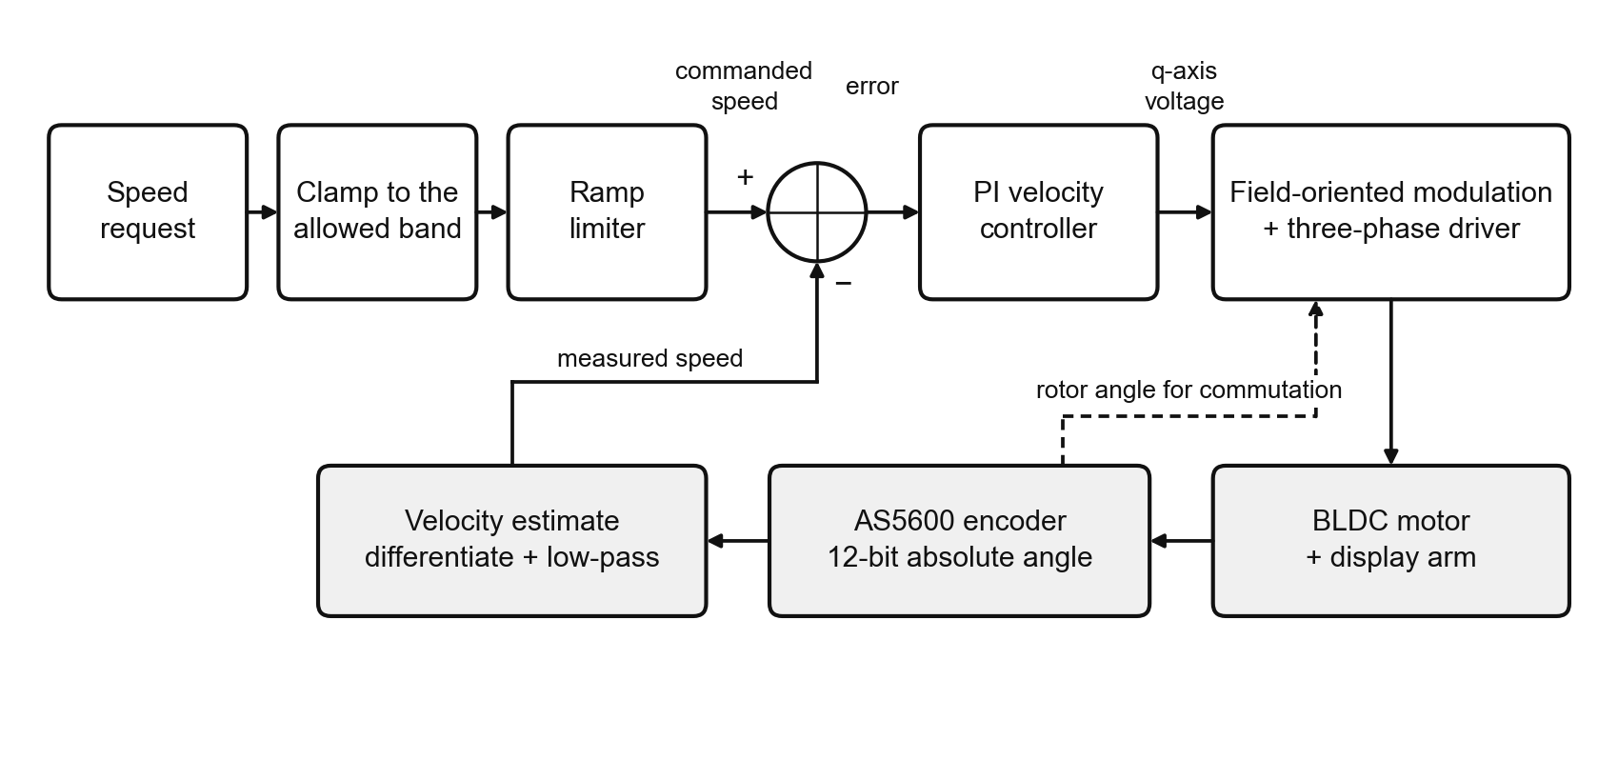
Figure 18: Closed-loop velocity control structure. The encoder serves both the velocity feedback path and the commutation of the motor.
The controller is proportional-integral rather than proportional-integral-derivative. The velocity signal is obtained by differentiating a quantised angle measurement, and, as Section 7.4 describes, that operation is inherently noisy at this resolution and loop rate; differentiating it a second time would amplify that noise into the commanded voltage to no useful end. Integral action is retained because friction and cogging dominate the load at the low end of the operating range and a proportional term alone leaves a standing error there.

7.3.1 Rate limiting of the setpoint
A ramp generator sits between the user's setpoint and the controller, limiting the rate at which the commanded speed may change. It is applied in both directions and between arbitrary speeds, so that a change of setpoint made while the fan is already running is limited in exactly the same way as the initial spin-up.
This exists for three reasons, of which the first is the most important. There is no current sensing anywhere in this system, so the firmware has no direct measurement of what the motor is drawing and no means of limiting it in closed loop. Torque, and therefore current, rises above its steady-state value only when the arm is being accelerated; bounding the rate of change of the setpoint is consequently the only current limiter available, and it is an effective one because it bounds the acceleration directly. Second, a step change in setpoint applied to a high-inertia arm demands a torque impulse the controller will attempt to supply by saturating its output. Third, applying the ramp during deceleration is what makes a normal stop a controlled deceleration rather than a coast: the motor continues to regulate all the way down, and the drive is only removed once the ramp has reached zero and the arm has actually stopped.
A second, independent bound is placed on the controller's output voltage. This limit was chosen from the driver's own ratings rather than from what the motor requires: the worst case is zero speed with the controller saturated, where the winding sees the full commanded voltage with no back-electromotive force opposing it, and the limit is set so that the resulting current remains below both the driver's peak rating and the lower bound of its overcurrent protection window. Sitting inside that window is the worst of the available choices, because a device at one end of the manufacturing distribution latches off while a device at the other end simply overheats. The measured voltage demand across the tested speed range is reported in Chapter 8 and is far below this limit; the limit exists for the transient and fault cases, not for normal running.
One further detail of the ramp is worth stating because it prevents a specific hazard. When the drive is enabled, the ramp is initialised from the arm's measured speed rather than from zero. An outrunner carrying a long arm takes a considerable time to coast to rest, so restarting while the arm is still turning is easy to do. Beginning the ramp at zero would present the controller with a large negative error, which it would obey by braking the arm electrically — pushing energy back into a supply that cannot absorb it, for the reasons set out in Section 7.8.

7.3.2 Operating state machine
The fan's behaviour is organised as the five-state machine of Figure 19. The distinction that carries the most weight is between stopping and idle. Stopping means the ramp is still running down and the motor is still regulating; idle means the ramp has reached zero, the arm has come to rest, and the drive has been removed. Holding those apart is what allows a stop to be a controlled deceleration, and it is also what prevents the drive re-energising if the shaft is subsequently turned by hand.
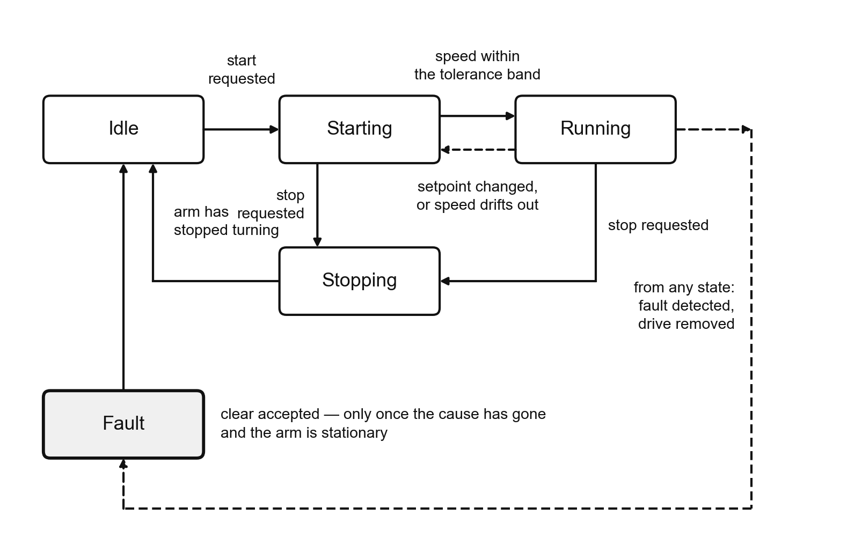
Figure 19: Operating state machine. Any state may transition to the fault state; the return to idle is guarded, as described in Section 7.8.
The transition from starting to running is made when the ramp has arrived at the setpoint and the measured speed lies within a tolerance band around it. The reverse transition occurs when the setpoint is moved or the measured speed leaves the band, so that the interface reports the fan as settling rather than as running whenever it is not actually holding the requested speed. The fault state is reachable from any other state and is described in Section 7.8; the return from it to idle is guarded rather than automatic.

7.4 Rotational Position Measurement
The system uses two independent angular references, one on each side of the rotating interface, and both are necessary. This section explains what each provides, why the rotor is not simply told where it is by the stator, and what the chosen scheme costs.

7.4.1 The two references
On the stator side, a magnetic encoder integrated into the motor reports absolute angular position over a full turn at twelve-bit resolution, satisfying FR10. Because the arm is bolted directly to the rotating face of the outrunner with no gearing, the ratio between motor and display is exactly one to one, and this sensor is therefore not merely measuring motor shaft position — it is measuring the absolute angular position of the display arm itself, expressed in the stator's frame of reference. It serves both the commutation and the velocity feedback described in Section 7.3.
On the rotor side, a Hall-effect sensor passes a single magnet fixed to the stator body once per revolution. Each pulse establishes two things: an angular datum, being the known direction in which the arm points at that instant, and, by the interval between consecutive pulses, the duration of the revolution just completed. These are the only pieces of angular information available on the rotating side, and they arrive once per revolution.

7.4.2 Why the rotor is not clocked over the radio
It is tempting to observe that the stator already knows the arm's absolute angle continuously, and to conclude that it should simply send that angle to the rotor. This was considered and rejected, and the reasoning is the most important design decision in this section.
The cadence required is the issue. With 180 angular sectors per revolution, at the design speed of 700 rpm a fresh column of colour data is due every 476 µs. Radio latency across the inter-processor link is of the order of milliseconds and, more damagingly, it varies from packet to packet: the link shares a radio with the access point, retransmits when a frame is lost, and offers no timing guarantee of any kind. A message-based scheme could not deliver a position update every 476 µs, and even if it could, the jitter on arrival would appear directly as angular jitter in the image. Streaming position over the radio is not merely slow for this purpose; it is unsuitable in kind.
The rotor therefore derives its own angle locally and is never clocked over the link. The stator's encoder is used for motor control, and the rotor's Hall sensor is used for display timing, and the two are not synchronised to one another. The benefit extends beyond timing: because the link carries no timing information at all, a lost or delayed packet cannot disturb the image. The link is left to carry only content and slow, idempotent commands, which is a far weaker requirement than a real-time one.

7.4.3 Angular interpolation between pulses
Between pulses the rotor interpolates. The duration of the previous revolution is taken as the estimate of the current one, and the angular sector currently under the arm is obtained from the time elapsed since the last pulse as a proportion of that duration, as illustrated in Figure 20. The display loop is driven by this sector changing rather than by a fixed clock: the sector is the clock. Deriving the painting cadence from the angle in this way means the display follows the arm through acceleration and deceleration without any rate tracking of its own.
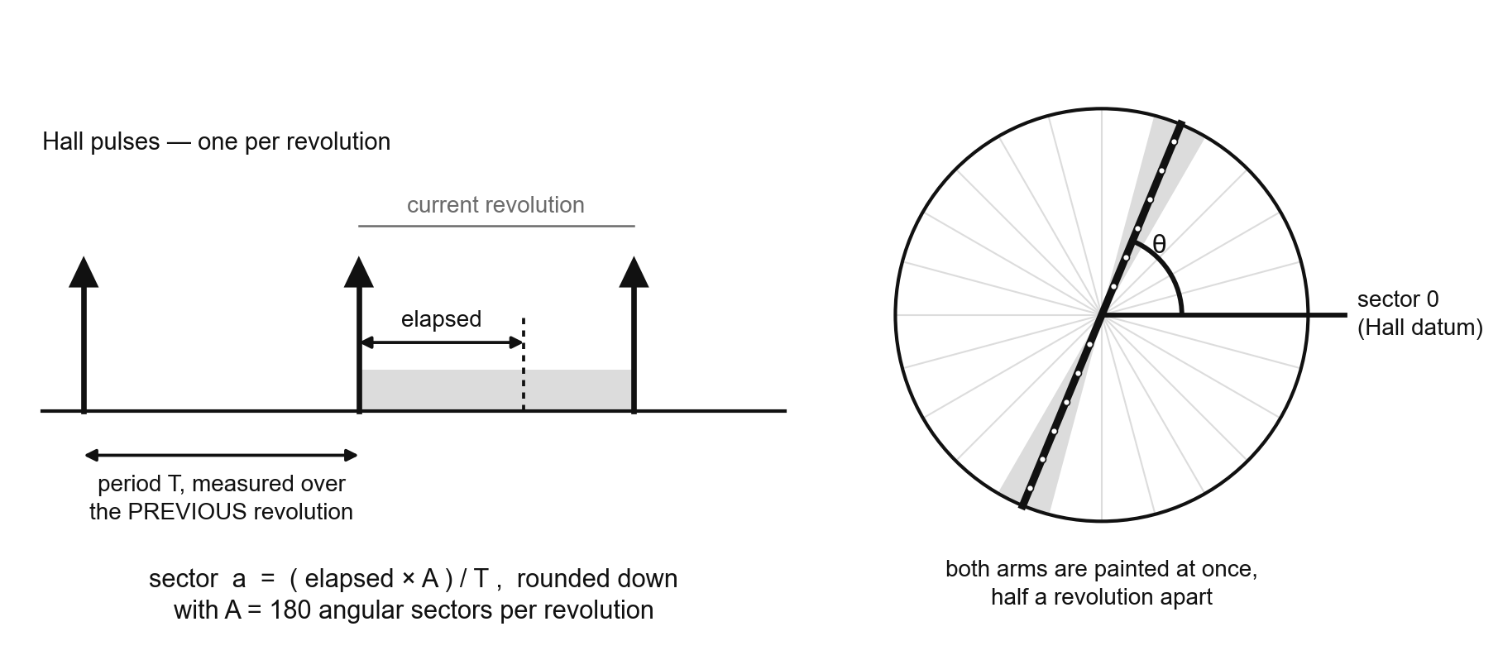
Figure 20: Angular interpolation. The revolution period measured over the previous revolution is applied to the current one to place the arm within one of 180 angular sectors.
The cost of this scheme should be stated plainly. The period being applied describes the revolution that has already finished, not the one in progress, so the interpolated angle is only as accurate as the assumption that rotation is steady. Under constant speed the assumption is sound. During acceleration or deceleration the applied period is stale, and the angular error grows through the revolution before being corrected at the next pulse. The design accepts this: the display is intended to be viewed at a held speed, and the error is bounded by one revolution because every pulse re-establishes the datum from scratch.
Two related decisions follow. If the arm slows after its period was measured, the interpolated sector can run past the end of a revolution before the next pulse arrives. Rather than wrapping around — which would paint the image backwards over itself and produce a visibly corrupted display — the sector is held at the last valid value until the next pulse resynchronises it. The occurrences are counted and reported in telemetry, so that the condition is visible rather than silent. Separately, implausible intervals between pulses are rejected as noise. The bounds on that test are set deliberately wide, because the two error cases are not symmetric: acting on a spurious period corrupts a single revolution and corrects itself at the next pulse, whereas rejecting a genuine pulse leaves the angular datum stale and the whole image drifts until another is accepted. Being permissive is the safer error.
For the same reason, the test for whether the arm has stopped is expressed relative to the last measured period rather than as a fixed timeout. A fixed threshold that is correct at the design speed declares the arm stopped while it is being turned slowly by hand on the bench, and the display never paints; scaling the threshold with the measured period makes one rule work across the whole range.

7.4.4 Velocity measurement near standstill
A twelve-bit absolute encoder resolves 0.088° per count. When angle is differentiated at a loop rate of the order of a kilohertz, the sampling interval is well under a millisecond, and a single count of measurement dither therefore differentiates to a velocity of tens of revolutions per minute. A stationary shaft consequently produces a non-zero, fluctuating velocity estimate, and no amount of filtering removes it without also removing the dynamics the controller needs.
For the control loop this is harmless: at any operating speed the real signal is far larger than the dither, and the low-pass filter smooths what remains. It is not harmless for any decision that asks whether the arm has stopped. Two such decisions exist and both matter — the transition from stopping to idle in Figure 19, and the refusal to clear a latched motion fault while the arm is still turning, described in Section 7.8. If either test used the differentiated estimate, it would never be satisfied, the fan would never report itself idle, and a latched fault could never be cleared at all.
A second speed estimate is therefore computed for these decisions, based on angular displacement over a fixed window of a quarter of a second rather than on differentiation over a single sample interval. The improvement comes from the length of the baseline: over a window of that duration, even a very slow rotation accumulates tens of counts of genuine travel, against the same single count of dither. The same sensor yields a discrimination between motion and stillness that is better by more than two orders of magnitude, with no filtering at all. The two estimates coexist deliberately — the fast one is what the controller needs, and the slow one is what every question about stillness is answered with.

7.5 Image Representation and Display
This section describes how a picture supplied by a user becomes light. It covers the geometry of the display, the format in which image data is represented, the decision about where the conversion into that format is performed, and how a column of colour is addressed at display time.

7.5.1 Display geometry
A single continuous strip of individually addressable RGB LEDs (FR09) runs across the full diameter of the rotor, so that the centre of the strip lies on the axis of rotation and each half of the strip forms one arm. The arms are therefore 180° apart by construction, and a half revolution is sufficient to paint the whole disc. The refresh rate of the display is consequently twice the rotational rate, which at the design speed of 700 rpm gives 23.3 Hz and satisfies TPM09. The strip as built provides eighteen LEDs per arm, which is below both TPM06's target of twenty-eight and its lower bound of twenty-five; this is a property of the hardware that the software takes as given. The image format described below carries the geometry explicitly rather than assuming it, so a longer strip requires no change to the firmware.
The angular resolution is a software choice rather than a hardware one, and 180 sectors per revolution were adopted, meeting the lower bound of TPM07 rather than its target of 360. The choice is bounded from above by the time available to transmit one column: at 700 rpm with 180 sectors a column is due every 476 µs, against roughly 150 µs to clock a full strip update out over the serial interface. Doubling the angular resolution to 360 sectors would halve the budget to 238 µs, which still fits but leaves considerably less slack for everything else the display processor must do between columns. The lower figure was taken during bring-up in exchange for margin, and can be raised without any change to the format.

7.5.2 Polar representation
A conventional image is a rectangular grid of pixels; the display is a set of discrete radii swept through a set of discrete angles. Rendering an image therefore requires resampling it from Cartesian into polar coordinates: for every angular sector and every radial position, the colour is taken from the point of the source image on which that LED falls at that angle. The result is a two-dimensional array indexed by angle and radius, illustrated in Figure 21.
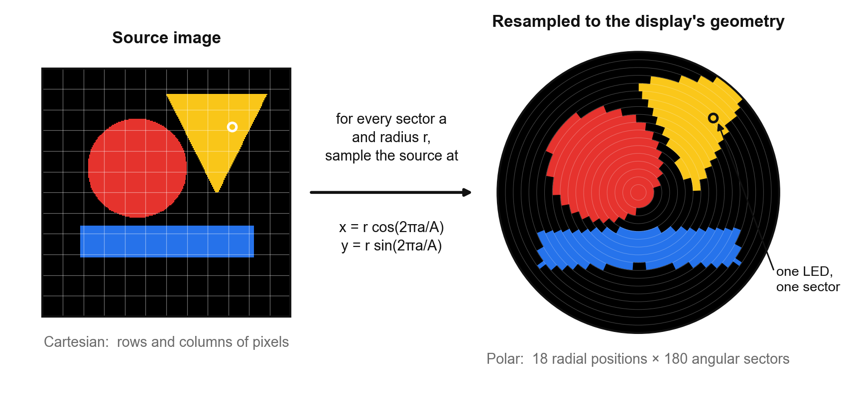
Figure 21: Resampling from Cartesian to polar coordinates. The radial rings are drawn to show the discrete geometry; the stepped edges are the true consequence of sampling at eighteen radii and 180 angles.
Two properties of the mapping are visible in the figure and are worth noting, because they are characteristics of this display technology rather than defects. Angular sectors are of constant angular width, so the arc length they subtend grows with radius, and detail near the rim is coarser than detail near the hub. Conversely, all eighteen radial samples of every sector converge at the centre, so the region near the axis is heavily oversampled and any detail placed there is smeared. Composing content that suits a circular, radially-sampled display is a matter for whoever supplies the image, and the interface described in Section 7.7 shows the user this effect before they commit to an upload.

7.5.3 The frame container
The resampled data is carried in a small purpose-defined container, referred to here as the frame file. It begins with a sixteen-byte header carrying a magic number, a format version, the radial and angular resolutions, the number of frames, the intended frame rate, a flag indicating whether playback loops, and the length of the payload. The payload follows as a plain sequence of bytes, three per LED position. The header makes the file self-describing, so that a file already resident in the device's storage can be validated and played back without any accompanying metadata, and so that a mismatch between the geometry of the content and the geometry of the strip can be detected rather than producing a corrupted image.
The ordering of the payload is the significant decision. The data is stored angle-major: all radial positions of angular sector zero, then all radial positions of sector one, and so on, with the byte at index c of radial position r within sector a of frame f found at
offset(f, a, r, c) = ((f · A + a) · R + r) · 3 + c
where A is the number of angular sectors and R the number of radial positions. The consequence is that the data for a single column — one complete arm at one angle — occupies a contiguous run of bytes, as shown in Figure 22. At display time that run can be handed to the LED driver exactly as it is stored, with no gathering, no stride and no rearrangement. The alternative ordering, radius-major, would require the display loop to collect eighteen bytes scattered at a stride through memory for every column, several thousand times per second, in the tightest timing loop in the system. Choosing the layout to suit the consumer rather than the producer removes that work entirely.
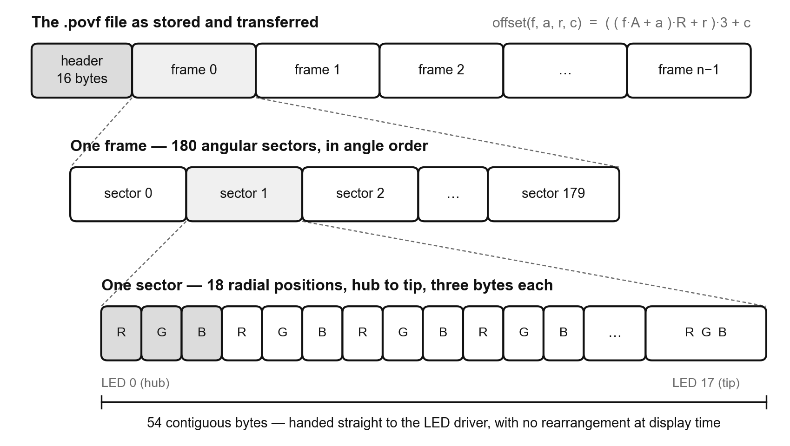
Figure 22: Layout of the frame container. Storing the payload angle-major makes each display column a contiguous run of bytes.

7.5.4 Where the conversion is performed
FR08 places the conversion of an uploaded image into a polar column map on the device. In this implementation it is performed in the browser instead, and the device receives data that is already in the format the rotor reads. This is a deliberate departure from the specification as written, and it is set out here in full rather than left implicit.
The argument for moving the work rests on four considerations. First, and decisively, converting an image on the device requires first decoding it, and TPM11 requires JPEG, PNG and animated GIF to be accepted. FR12 forbids the use of pre-built libraries in the firmware, so meeting both requirements literally would mean writing three image decoders from scratch for a memory-constrained microcontroller. That is a very large quantity of firmware, of a kind that contributes nothing to the mechatronic content of the project, and it would have to hold a decoded frame in a memory that is already committed elsewhere. Second, every browser already contains those decoders, thoroughly tested, at no cost in device flash or device memory. Third, performing the conversion in the browser makes an honest preview possible: the user sees exactly what the LEDs will paint, including the radial smear at the hub and the stepping at the rim, before deciding to upload. Fourth, the payload the device receives becomes fixed in size and predictable regardless of the source file, which makes it possible to check available storage before a transfer begins rather than discovering the problem partway through.
The case against is that it departs from the requirement as written, and that it makes the interface a functional component of the system rather than merely a control panel. The first is acknowledged. The second is mitigated by the format being explicit and self-describing, so that any producer conforming to it — including, if it were ever wanted, an on-device converter — is interchangeable.
The intent of FR08 is that the fan displays the user's image correctly, and that intent is fully met: an arbitrary JPEG, PNG or animated GIF supplied through the interface appears on the arm, correctly mapped, with animation preserved. What has changed is which processor performs the coordinate transform. The split places each half of the work where the hardware for it already exists — decoding and resampling on a general-purpose machine with a decoder and a display, angular tracking and column clocking on the microcontroller physically attached to the sensor and the strip. The firmware retains everything the brief is substantively concerned with: rotor angle tracking, Hall sensing, motor control, wireless synchronisation and driving the LED strip. This deviation should be raised explicitly with the supervisor rather than presented as compliance.

7.5.5 Column addressing and playback
At display time the rotor holds an interpolated angular sector, obtained as described in Section 7.4. The column for the first arm is the run of bytes belonging to that sector; the column for the second arm is the run belonging to the sector half a revolution away, obtained by adding half the number of sectors and wrapping. Both arms' data is already present in the same buffer, so no mirroring, reversal or arithmetic on the image is performed at display time — two lookups and one transfer to the strip. The physical strip is indexed outward on one arm and inward on the other, since it runs continuously through the hub, and that reversal is handled once in the LED driver rather than in the image data.
Gamma correction is applied once, in the browser, before the bytes are written into the file. Source images are encoded in a non-linear colour space whereas LED brightness is very nearly linear in duty cycle, so writing raw values to the strip produces washed-out midtones. The firmware writes the received bytes to the strip unmodified; applying gamma a second time on the device would crush the midtones instead.
That decision determines how brightness control is implemented, and the two are directly connected. Reducing brightness by scaling the RGB values would undo the gamma work and, worse, would discard colour resolution precisely where there is least of it: scaling an eight-bit value to a quarter of its magnitude leaves two bits of it. The LED driver chips used carry a separate five-bit global current field which attenuates the whole strip in hardware, downstream of the colour data. Brightness is therefore set through that field, and the colour bytes are never touched. The user's brightness control (Section 7.7) maps directly onto it.
Animation (FR13) is played by advancing a frame index at the frame rate recorded in the file's header, independently of how fast the arm is rotating. This is a deliberate separation: an animation should play at the rate at which it was authored, not faster because the fan happens to be spinning more quickly. The rate is bounded above by the display refresh rate, since a frame cannot be shown in less than the time it takes to paint one, and TPM12's target of 12 fps sits comfortably below the 23.3 Hz refresh available at the design speed.
Finally, the rotor holds a generated fallback pattern for the case where no content has been received, so that the strip shows something diagnostic rather than nothing when the link is down or the device has just been powered on. A separate diagnostic mode steps the entire strip through red, green and blue once per accepted revolution pulse. This is deliberately a mode rather than an item of content: a frame file is indexed by angle, so anything expressible in one is a function of where the arm is pointing and would flash identically whether or not the Hall sensor were working. Testing the sensor requires something indexed by revolution count, which only the display loop has, so the interface selects a mode in this one case rather than a file.

7.6 Inter-Processor Communication
The stator and rotor coordinate over a connectionless wireless protocol that operates alongside the access point on the same radio. It was chosen in preference to running a conventional network connection over the access point itself for three reasons: the rotor would otherwise have to associate with the access point and maintain a socket, consuming both battery and airtime and competing with the browser for the server's attention; the protocol has substantially lower latency because there is no connection to establish or maintain; and a connectionless protocol degrades gracefully, since a lost message is simply a lost message rather than a stalled stream. Its nominal rate of 1 Mbps (Espressif, 2026) is ample for the traffic described below.
One property of the protocol dictates a design decision: it neither scans for networks nor roams between channels. Both ends must already be operating on the same radio channel before any communication is possible, and a mismatch produces complete silence with no error reported at either end, because the packets are simply transmitted where nobody is listening. The channel is therefore fixed by design and shared with the access point, rather than being negotiated or allowed to be selected automatically at start-up.
Peer discovery is by beacon rather than by hardcoded address. The stator broadcasts a short announcement at a regular interval; the rotor hears it, learns the stator's address, and registers it as a peer. Neither board's hardware address appears in the other's firmware, so either can be replaced or reflashed without touching the other — which matters for a project in which both boards are development hardware and either may be swapped during fault-finding.

7.6.1 Message set
Three classes of message cross the link. Telemetry travels from rotor to stator twice per second, carrying the rotor's own measurement of speed, its column painting rate, its counts of rejected pulses and interpolation overruns, its link and content status, and, where the hardware provides it, battery state. Once the arm is turning there is no wired connection to the rotor at all, so this stream is the only means of observing the rotating half of the machine, and it is sized accordingly.
Commands travel from stator to rotor and carry the requested brightness, the identifier of the content to be displayed, and flags controlling whether the display is enabled and whether the diagnostic mode is active. They are small and idempotent, and are retransmitted with every beacon rather than acknowledged; a dropped command is therefore corrected within a beacon interval with no protocol machinery at all. Making the commands idempotent is what allows this, and was a deliberate choice over an acknowledged scheme.
Content transfer is the third class and is described below. All messages are fixed-layout structures with explicit field widths, and a protocol version is carried in every message and checked on receipt, because the two processors are of different architectures and a silent disagreement about structure layout would produce plausible but wrong numbers rather than a visible error.

7.6.2 Why content is pushed once rather than streamed
Content is transferred into the rotor's memory in full, once, when it is selected, and is thereafter played back locally. It is never streamed frame by frame. The arithmetic settles this without needing a measurement. A single frame at the display's geometry is 9 720 bytes. At the target animation rate of 12 fps (TPM12) that is approximately 117 kB/s of sustained payload, and it would have to arrive with latency bounded to well under one frame period, over a link that shares its radio with an access point and offers no delivery guarantee. Streaming is not marginally too slow for this purpose; it is not achievable at all.
Pushing once removes the requirement entirely. The transfer takes a number of seconds and happens when the user selects an image, which is a moment at which a progress indicator is entirely acceptable; thereafter the display reads from local memory at whatever rate the arm demands, and the radio is idle. The rotor processor was specified with external memory sufficient to hold a full-length animation for exactly this reason, and it is the availability of that memory that makes the push-once model possible.

7.6.3 Transfer protocol and reliability
The transfer proceeds as shown in Figure 23. An opening message announces the geometry, the total payload length and a transfer identifier; the receiver validates that the declared geometry actually describes the declared length, reserves a buffer, and accepts. The payload then follows as a sequence of chunks, each carrying its own byte offset. A closing message carries the total length and a checksum, and the receiver replies with the outcome.
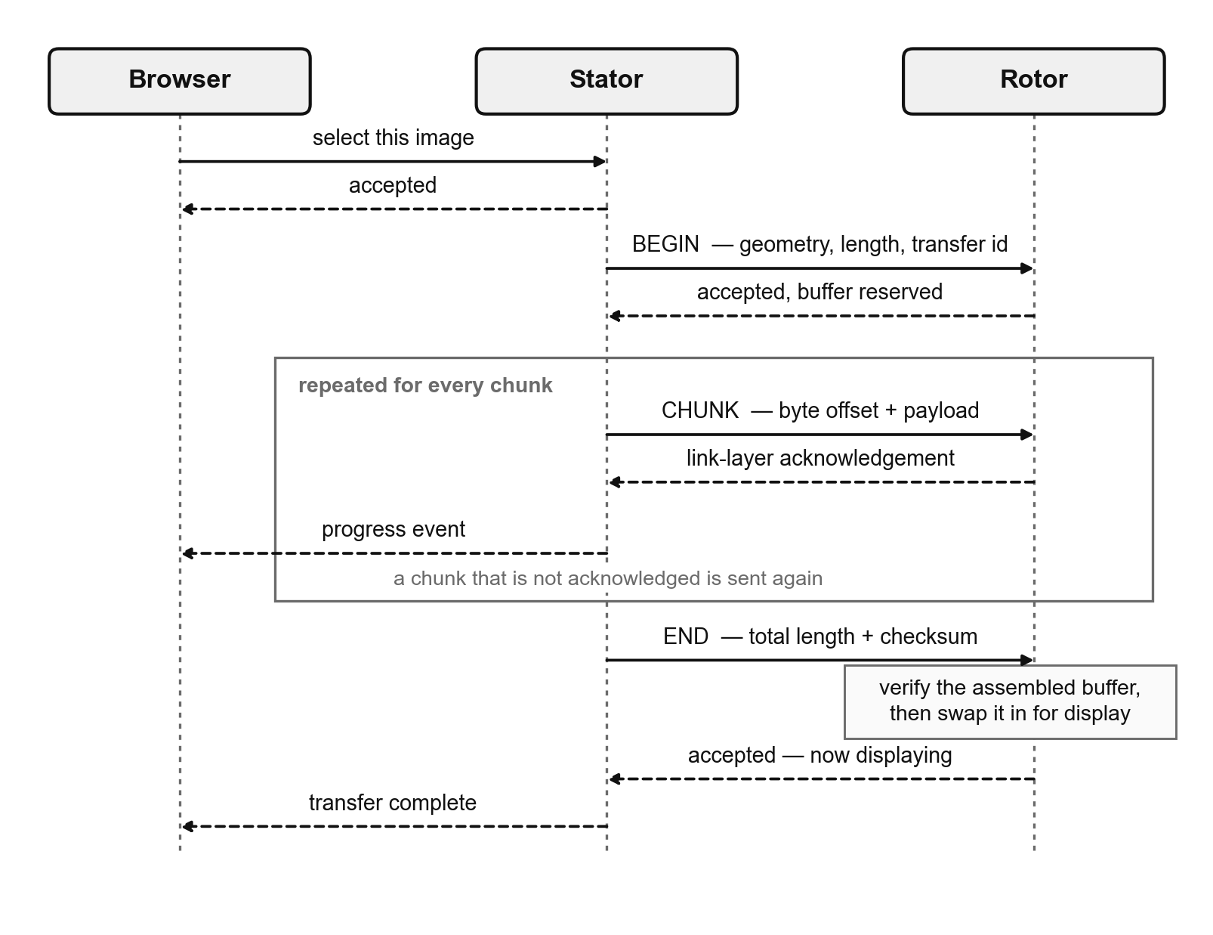
Figure 23: Message sequence for a content transfer. Flow control rides on the link layer's own acknowledgement, and the transfer is verified as a whole before it is displayed.
Flow control rides on the link layer's own acknowledgement rather than on an application-level acknowledgement for each chunk. The transmitter sends one chunk, waits to learn from the radio whether the peer acknowledged the frame, retries on failure and advances on success. This yields ordered, reliable delivery at one round trip per chunk with no protocol of the project's own to get wrong, and progress reported to the user is genuine — it counts bytes the receiver has acknowledged, not bytes handed to the radio. The cost is that a stop-and-wait scheme is slower than a sliding window would be; correctness was preferred, and the measured throughput reported in Chapter 8 determines whether more is warranted.
That choice has a consequence which must be designed for. The transmitter retries when an acknowledgement is lost, and an acknowledgement can be lost even though the chunk it referred to arrived perfectly well — so the receiver can legitimately see the same chunk twice. Any integrity check accumulated as data arrives would therefore count duplicated bytes twice and fail transfers that were in fact complete and correct. Both of the receiver's integrity measures are consequently made insensitive to duplication: the count of bytes received is tracked as the highest offset reached rather than as a running total of arrivals, and the checksum is computed over the assembled buffer once at the end rather than incrementally. Both are immune to duplication and to reordering alike.
The receiver is double buffered. A transfer takes seconds, during which the arm may be turning and displaying the previous image, so incoming data is written into whichever of two permanently allocated buffers is not currently being displayed. Only when the closing message has been received and the assembled buffer has passed both checks is the new buffer made the active one, by a single pointer exchange. A transfer that fails, or is abandoned partway through, therefore leaves the current image entirely untouched. The transfer identifier carried in every message serves the same purpose from the other direction: if the user selects a different image while a push is in progress, packets still in flight from the abandoned transfer are discarded rather than written into the new buffer.
One further behaviour was added for operational rather than protocol reasons. Content is pushed when the user selects it, so a rotor powered on after the selection was made — or one that restarts mid-demonstration — would hold nothing while the interface continued to report an image as selected. The stator therefore re-pushes the current selection whenever telemetry indicates that the rotor is holding no content, rate-limited so that a transfer which keeps failing retries occasionally rather than continuously.

7.7 User Interface
SR12 and FR05 require the interface to be reachable from ordinary devices without installing anything. The implementation serves a web application from the stator itself: the stator runs its own wireless access point, the user joins that network from a phone, tablet or laptop, and opens a page. Nothing is installed, no existing network is required, and no application need be maintained for more than one platform. At an open day, where no infrastructure can be assumed and the users are members of the public, this is the only approach among those considered that does not require something of the visitor.
The interface is shown in Figure 24. It is organised into three panels: operating controls, live status, and content selection with a preview.
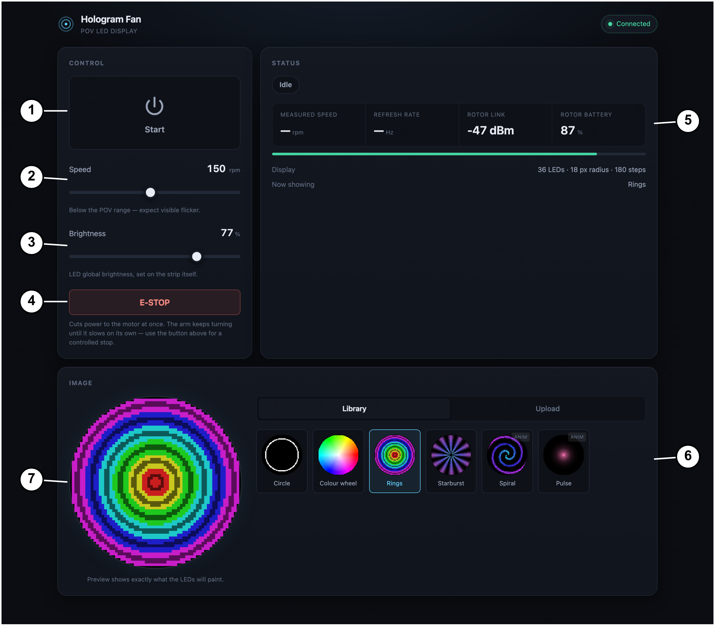
Figure 24: The web interface served by the stator, showing (1) start and stop, (2) speed setpoint, (3) brightness, (4) emergency stop, (5) live telemetry, (6) the content library, and (7) a preview of exactly what the LEDs will paint. Shown running against the development simulator described in Section 7.7.3, so the telemetry values are simulated rather than measured; battery state in particular is reported as unavailable by the real device, which has no sense circuit fitted.

7.7.1 The interface contract
Two distinct channels connect the browser to the device, shown in Figure 25. User actions are sent as individual requests — one request per action, each returning success or an error. Telemetry travels the other way over a single connection that the device holds open and writes to twice per second.
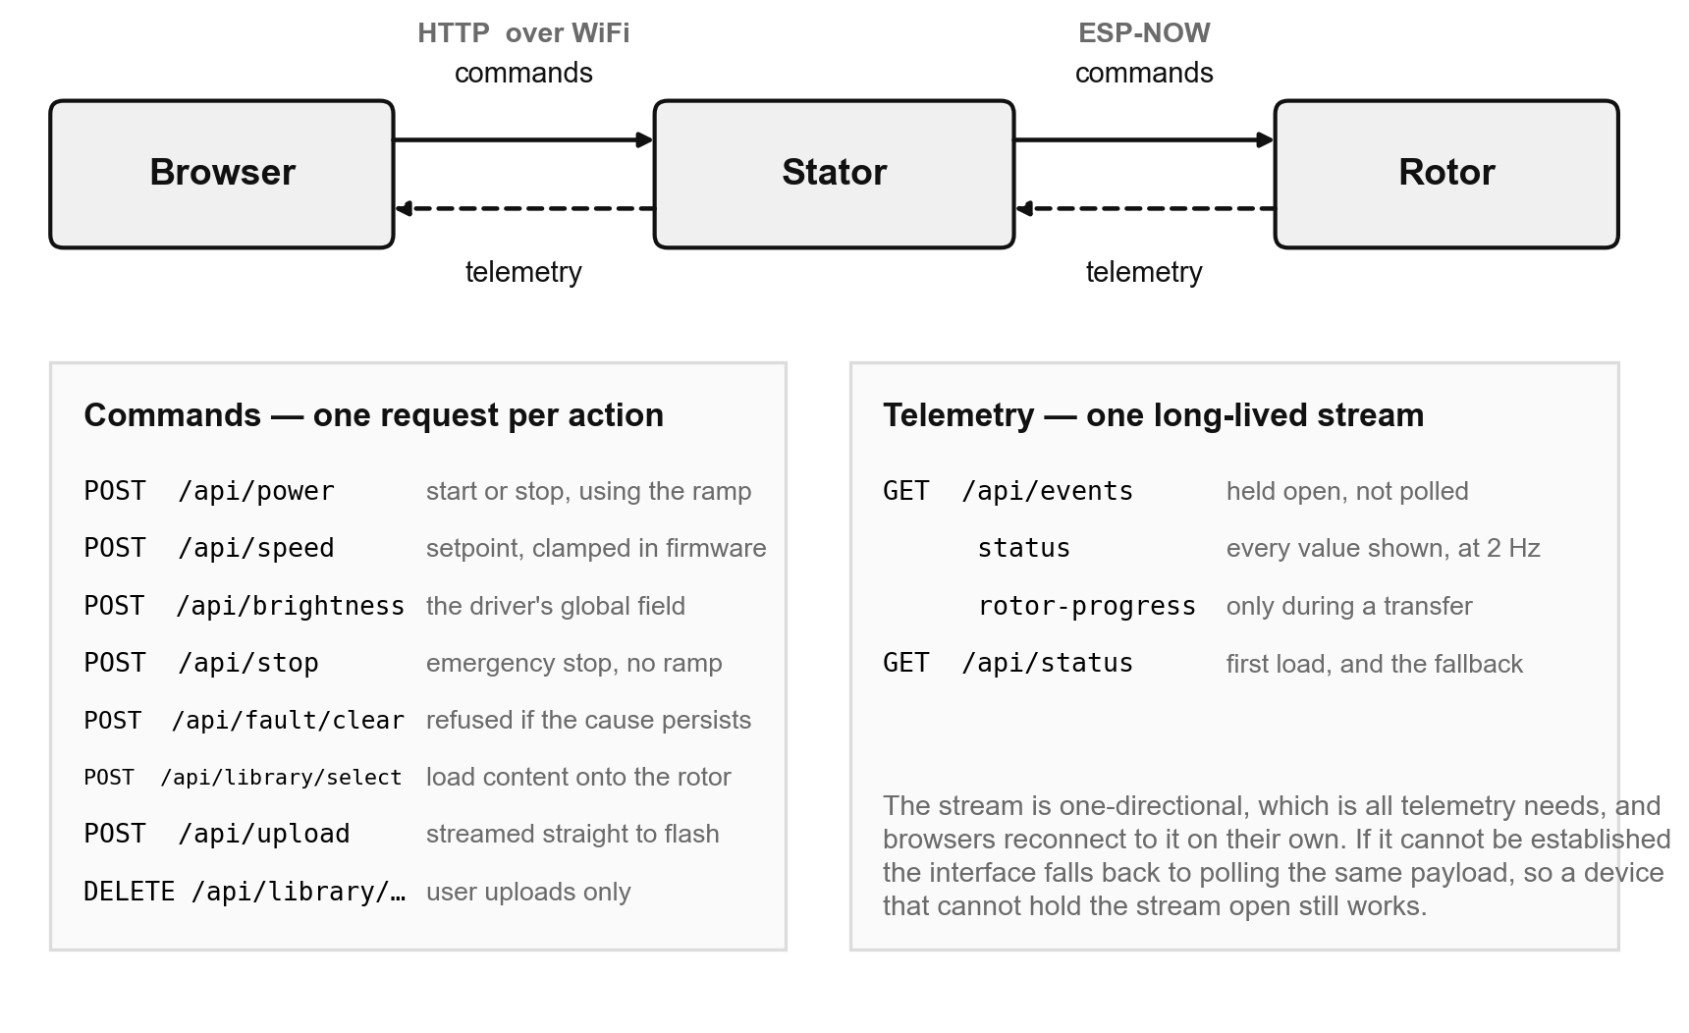
Figure 25: The interface contract. Commands are individual requests; telemetry is a single stream held open by the device, with polling as a fallback.
A held-open one-directional stream was chosen in preference to a bidirectional socket protocol. Telemetry only ever travels from device to browser, so the return path a bidirectional protocol provides would be unused; the simpler mechanism is markedly cheaper for the device to serve, which matters directly given Section 7.2; and browsers reconnect to a dropped stream automatically, without any reconnection logic having to be written. Where the stream cannot be established at all, the interface falls back to requesting the same payload at a fixed interval, so a client or network that cannot sustain a long-lived connection still works, at the cost of a slightly less responsive readout.
Errors are returned as complete sentences intended to be read by whoever is standing in front of the fan, and the interface displays them as received rather than mapping codes to text of its own. This keeps a single authoritative wording, in the firmware, for what has gone wrong and what to do about it.

7.7.2 Controls, upload and clamping
The controls provided satisfy SR11 and FR06: starting and stopping the fan under the ramp of Section 7.3, setting the speed, setting the brightness, clearing a latched fault, and an emergency stop presented separately and prominently. The status panel reports the operating state, the measured speed, the resulting display refresh rate, the state of the link to the rotor and the content currently loaded.
Content upload satisfies SR10 and FR07. The browser accepts JPEG, PNG and animated GIF (TPM11), converts the file as described in Section 7.5, and uploads the converted payload. Two properties of the upload path are design decisions rather than implementation detail. The upload is streamed to the filesystem as it arrives and is never buffered whole, because a full-length animation is larger than the stator's entire working memory; and the file header is validated as soon as those first bytes have arrived, so that a malformed or hostile payload is rejected after sixteen bytes rather than after a megabyte has been written. Available space is checked against the declared length before the file is opened at all, since the storage genuinely can be exhausted by two full-length animations, and any partial file is removed on every failure path including a client that disappears partway through.
The speed the interface offers is restricted to the range the firmware permits, and the firmware clamps every requested speed to that range again regardless of what arrives. The duplication is intentional. The interface restriction exists so that the readout can actually reach the value the user selected — a control offering speeds that are silently clamped would show a setpoint the fan never attains — while the firmware clamp exists because the interface is a convenience and cannot be trusted. Anything at all may arrive over the network, and the limit that matters is the one enforced by the processor that owns the motor. The same principle governs Section 7.8.
The interface is written in plain markup, styling and scripting with no framework, and the resulting bundle occupies a few tens of kilobytes on the device. This is a constraint rather than a preference: the interface shares the stator's flash memory with the content library, and the space a framework would occupy is space that would otherwise hold a user's animation.

7.7.3 Development against a simulated device
Writing the interface to a device that must be reflashed on every change is impractical, so a simulator was written to stand in for the stator during development. It implements the same interface contract, ramps a simulated motor, rate-limits the content transfer to a plausible throughput and reports faults on demand. The purpose is not convenience alone: a simulator that answered instantly and never failed would permit an interface that falls apart on real hardware, so it was written to reproduce the device's slow and awkward behaviours deliberately. It also serves as an executable statement of the contract, against which the firmware was subsequently written.

7.8 Fault Detection and Safety
FR02 requires that electrical and mechanical fault conditions be detected and the system brought automatically to a safe stopped state, in support of SR02 and SR04. This section describes what is detected, how the system responds, and — equally importantly — what the software deliberately does not claim to protect against.

7.8.1 Detected conditions
The conditions monitored are listed in Table 6, together with the response and the condition for clearing. They fall into two groups, and the distinction is worth making because it determines how much confidence each deserves. One condition is reported by hardware: the motor driver asserts a dedicated fault output on overcurrent or over-temperature, and when it does so it has already shut a channel down. Everything else is inferred by the firmware from the behaviour of the system, and an inference can be wrong.
Table 6: Fault conditions, responses and clearing criteria.
Code | Condition | Detected by | Cleared when
E01 | The position sensor cannot see its magnet | Sensor status, reported by the encoder itself | The sensor reports a healthy magnet
E02 | Communication with the position sensor has failed | Failed bus transactions | The sensor responds again
E03 | Sustained tracking error — the requested speed cannot be reached | Measured speed outside a tolerance band for a sustained period, tested only once the ramp has arrived | The arm has come to rest
E04 | Driver overcurrent or over-temperature | Dedicated fault output from the driver — the only condition reported by hardware | The driver's latch is reset and the fault output releases
E05 | Stalled — under power but barely turning | Measured speed far below the setpoint, using the displacement-based estimate of Section 7.4.4 | The arm has come to rest
E06 | Overspeed or runaway | Measured speed above the permitted maximum by a fixed factor | The arm has come to rest
E08 | Excessive velocity ripple — probable mechanical imbalance | Peak-to-peak speed variation over one revolution, above a minimum speed | The arm has come to rest
E09 | The controller has run out of authority | Commanded voltage held near its own limit for a sustained period | The arm has come to rest

Two of the entries deserve explanation. The last, E09, watches the controller's own commanded voltage against the limit it is allowed. An earlier design watched an estimate of motor current instead, computed from the commanded voltage, a datasheet winding resistance and a back-electromotive-force constant. Since the system has no current sensing of any kind, that figure is a model rather than a measurement, and, as reported in Chapter 8, the model was demonstrably wrong. A protective function built on a wrong model is worse than no protective function at all: it stops the machine for no reason and teaches the operator to distrust the fault system. Commanded voltage requires no model — it is the quantity the controller directly sets — and saturation of it is the condition that precedes both an inability to reach speed and an excessive draw from the driver.
The other, E08, is an inference of a mechanical quantity from an electrical one, and its limits should be stated. No accelerometer is fitted, so vibration cannot be measured. An out-of-balance arm applies a disturbing torque once per revolution, which the velocity loop cannot flatten, so it appears as periodic velocity ripple; the peak-to-peak spread of measured speed over one revolution is therefore used as a proxy. The threshold must sit above the noise floor imposed by the encoder quantisation of Section 7.4.4, and that floor is not small. The honest consequence is that this detects gross imbalance only, and only while running. It is not a substitute for balancing the arm mechanically, and a subtle imbalance will pass it.

7.8.2 Latching and clearing
Faults latch. The first cause to be detected wins and is not overwritten by consequences of it, so that the reported fault describes what actually happened rather than what happened next, and the fan does not resume of its own accord when a transient condition passes. Clearing is an explicit action by the user.
A clear request is refused while the cause is still present, and the refusal is reported with a sentence explaining what remains wrong. For faults arising from motion, the test for whether the cause has gone is that the arm has actually stopped turning, evaluated using the displacement-based speed estimate of Section 7.4.4 for the reasons given there. This is a safety property, not a formality: clearing a fault re-enables the start control, and without this guard an operator could clear a fault and restart into an arm that is still coasting at speed. For the driver fault, the driver's own latch is reset before the condition is re-tested, so that a genuine overcurrent trip is recoverable from the interface rather than requiring the supply to be disconnected — but if it re-asserts immediately, the clear is refused.

7.8.3 Two stop behaviours
The system provides two distinct means of stopping, and they behave differently on purpose. A normal stop ramps the setpoint down at the same limited rate used for acceleration, with the motor regulating throughout, and removes the drive only once the arm has come to rest. An emergency stop removes the drive immediately, and the arm then coasts.
The reason the emergency stop does not brake is an energy argument. Decelerating a rotating mass electrically means the machine acts as a generator, and that energy must go somewhere. The direct-current supply here is a mains adapter, which cannot absorb returned energy, and no brake resistor is fitted. Braking a high-inertia arm hard would therefore raise the supply rail rather than dissipating the energy, exposing the driver to a voltage above its supply. The controlled ramp is safe because it is slow: shedding a limited number of revolutions per minute each second requires only a small braking torque, and friction performs much of the work, so the returned current is a trickle. A hard electrical brake is a different matter entirely, and coasting is the correct choice in its absence.
The consequence must be stated plainly, because it is counter-intuitive: the emergency stop does not stop the arm quickly. It removes drive quickly. The arm continues to turn for a considerable time afterwards. The interface says so, in those words, immediately beneath the control.

7.8.4 What the software does not protect against
Two limitations bound everything above and are stated here rather than left to be inferred.
First, software limits are not the safety mechanism. Requested speeds are clamped inside the firmware regardless of what the interface offers, as described in Section 7.7.2, precisely because the interface is a convenience that cannot be trusted; but a clamp in firmware is itself only a defence against a wrong request, not against a mechanical failure. Second, and more importantly, the physical guard required by SR01 and implemented under FR01 is what actually protects a person from the rotating arm. The stop control is a convenience. Given that an emergency stop removes drive rather than arresting motion, the guard is the only thing standing between a member of the public and a half-metre arm turning at several hundred revolutions per minute, and no amount of firmware changes that.
Finally, every fault is surfaced to the user as a readable sentence describing what has happened and what to do about it, rather than as a code alone. Codes are retained for the report and for diagnosis, but a member of the public standing in front of a stopped fan at an open day is told, for instance, that the fan cannot reach the speed it was asked for and to check that nothing is touching the arm.

7.9 Linear Rail
The linear rail was designed as a third subsystem with its own processor and wireless coordination, as described in Section 6.2, but its software was not implemented within the scope of this work.

